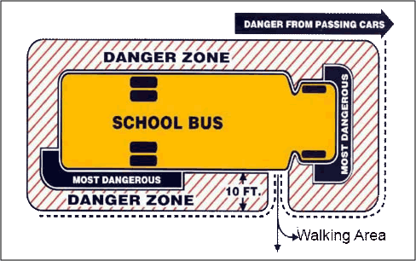

The privilege of riding a school bus carries with it some responsibilities. The superintendent and board of education establish rules for the conduct of students while riding the bus. Please encourage your children to take an active role and become more aware of their safety while riding the bus.

**Safety at the Bus Stop**

* + Arrive at the bus stop 5 minutes early
  + Wait for the bus to come to a **Complete** stop before walking to the bus
  + When crossing, wait for the driver to signal you to cross, walk ten feet in front of the bus so the driver can see you
  + Stay out of the Danger Zone (ten foot perimeter around the bus)
  + **Never run after the bus**
  + **Never stop to pick something up that may have been dropped - Wait until the bus pulls away.**

**Bus Rules**

* + Observe same conduct as in the classroom; Voice level 1, no loud screams or profane language.
  + Do not throw objects of any kind.
  + Report any acts of violence, misconduct or bullying to the driver.
  + Do not eat or drink on the bus.
  + Keep the bus clean.
  + Cooperate with the driver’s instructions when boarding, while on the bus and exiting the bus.
  + The possession or use of tobacco, alcohol and/or drugs is prohibited.
  + Do not be destructive (students will carry full responsibility for damage to any part of the bus).
  + Be seated immediately and stay in your seat (*bottom to bottom, back to back*).
  + Keep head, hands and feet inside the bus.
  + Bus driver is in charge and authorized to assign seats.
  + Failure to follow these rules could result in suspension from the bus.

Thank you for taking the time to go over these with your children, their safety is very important to us.

Sue Sharp

Director of Transportation

Dunklin R-5 School District